**Lab Task 5**

1. select * from salgrade;

1. select deptno from dept;

1. select ename, sal, sal+sal*.05 as "5%INCREMENT" from emp;

1. select ename, sal+sal*.05 as "new salary" from emp;

1. select * from emp where ename='BLAKE';

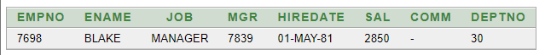

1. select ename||' '||'is hired on'||' '|| hiredate ||' '|| 'as a '||' '|| job from emp;

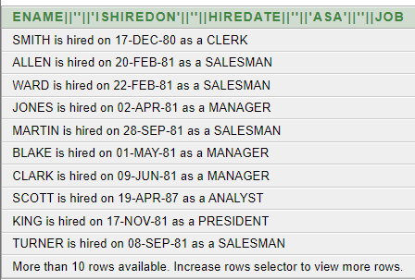

7.1) describe bonus;

7.2) describe emp;

7.3)describe salgrade;

7.4)describe dept;

8)select distinct job from emp;

